### A Circle Within a Circle Slice Form

A circle within a circle slice form. I created this slice form with geometry. I made a circle and divided it equally into parts. Each slit represents a 45-degree angle. The slits are at 0, 45, 90, 135, 180, 225, 270 and 315 degrees. The corresponding circle is similar at the equator. However, the two outermost corresponding circles needed to be skewed because the width of the ring that is being intersected is different than at the equator. I had to measure this with a ruler to adjust both outermost circle sizes. I am sure there is a mathematically equation that I could have used but it was easier just to measure the distance and adjust the size in the Silhouette Cameo designer software.

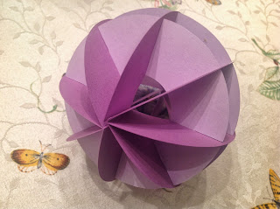

Notice the 45-degree angles

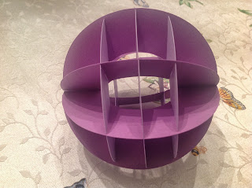

The circle in the middle (light purple) is similar to the corresponding circles (dark purple).

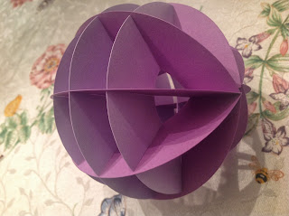

The two outermost circles (light purple) had to be measured with a ruler.